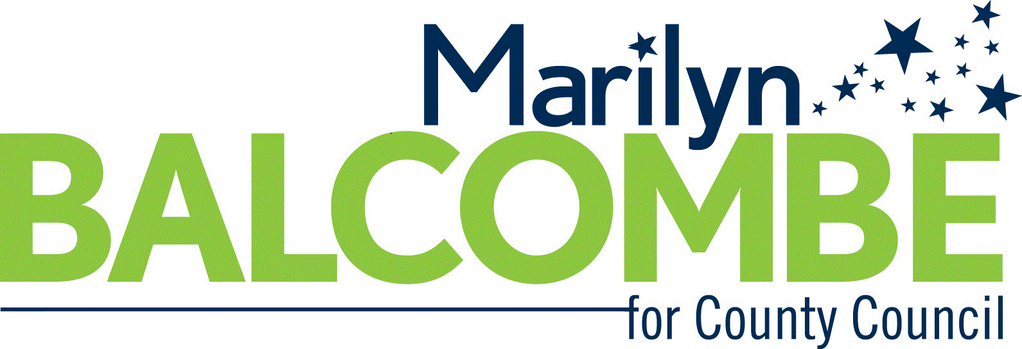
FRIENDS OF MARILYN BALCOMBE

Contribution Type ☐ Check ☐ Credit Card

Amount $ ______________ (maximum is $250)

Contributor Name__________________________________________________________

Home Address_____________________________________________________________

City / State / Zip____________________________________________________________

Montgomery County Resident (Circle) Yes No

Optional: Tel. ________________________ Email ________________________________

☐ I understand that State law and County regulations requires that a contribution be in my name be from my own funds. I hereby affirm that this contribution is being made from my personal bank account or credit card, billed to and paid by me for my personal use, and has no corporate or business affiliation.
☐ FOR RESIDENTS OF MONTGOMERY COUNTY, MD: I certify that I am a resident of Montgomery County Maryland.
SIGN HERE
Contributor’s Signature Date of Contribution
SEND CHECKS TO: Friends of Marilyn Balcombe
13518 Ansel Terrace
Germantown, MD 20874

CREDIT CARDS: www.marilynbalcombe.com

Friends of Marilyn Balcombe, Kathy Stevens, Treasurer

